

**SOFTWARE ENGINEERING ASSIGNMENT**

**MODULE: - 1**

**SE – Overview of IT Industry**

1. **What is Software? What is Software Engineering?**
2. **Explain types of software.**
3. **What is SDLC? Explain each phase of SDLC.**
4. **What is DFD? Create a DFD diagram on Flipkart.**
5. **What is Flow chart? Create a flowchart to make addition of two numbers.**
6. **What is Use Case diagram? Create a use-case on bill payment on Paytm.**
7. **What is software? What is Software Engineering?**

**Software: -**

* The software can be defined as a set of instructions, data or programs that is used to operate computers.

**Software Engineering: -**

* Software engineering is a detailed study of engineering to the design, development and maintenance of software.

1. **Explain types of Software?**

**There are 3 types of software: -**

**System Software:**



**[Fig: - 3.1 System Software]**

* This is the core software that manages hardware resources and provides essential services for computer operation Ex: - operating systems like Windows, Microsoft, Linux.
* It is like an interface between hardware and user application, it helps them to communicate with each other because hardware understands machine language.

**Application Software:**



**[Fig: - 3.1 Application Software]**

* Application Software, or App, is a kind of computer program that accomplishes specific functions. This specific function is determined as per the user’s requirement.
* For example, Microsoft Word, EXCEL, VLC media player, Firefox or Google Chrome.

**Programming software: -**

* A program that can be written in any programming language to perform specific task. Ex: Compiler, Interpreter.

1. **What is SDLC? Explain each phase of SDLC.**

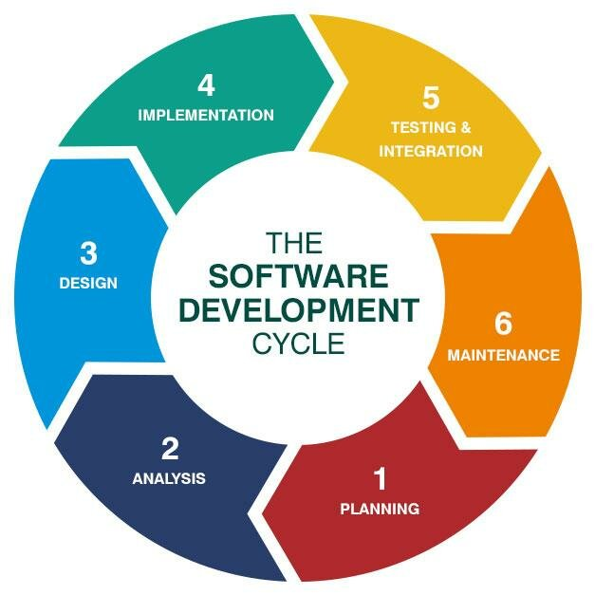

**[Fig: - 3.1 Software Development Life Cycle]**

* The SDLC stands for [Software Development Life Cycle] is a structured process used by software developers to plan, design, build, test and maintain software systems. Each phase has its own set of activities and objectives.

1. **Planning:**

* In this phase, project goals, requirements and constraints are identified. Key decisions are made including budgeting and project timelines.
* The planning phase involves identifying the scope of the project, gathering initial requirements and understanding what the project will achieve.

1. **Analysis:**

* This phase defines the requirements of the systems. This involves, surveys, and studying existing systems.
* In the Analysis phase detailed requirements are gathered and analysed.
* This phase focuses on understanding the needs of the users and the system.

**3.Design:**

* The design phase involves creating architecture of the system.
* The includes both high-level design and detailed design.

**4. Implementation:**

* Implementation is where our backend and frontend side applied.
* The implementation phase is where the actual coding and development of the software take place.

1. **Testing and Integration:**

* In this we have tested our project that it is good or not.
* This phase aims and executing test cases.
* Writing and executing test cases.

1. **Maintenance:**

* In this we maintain and upgrade the system or program.
* Adding a new features or enhancements.
* Updating the software to accommodate changes in technologies or user needs.
* Providing ongoing support and updates.

1. **What is DFD? Create a DFD diagram on Flipkart.**

* The flow of data if a system or process is represented by DFD. It is represented by DFD. It is also giving insight into the inputs and outputs of each entity and the process itself.

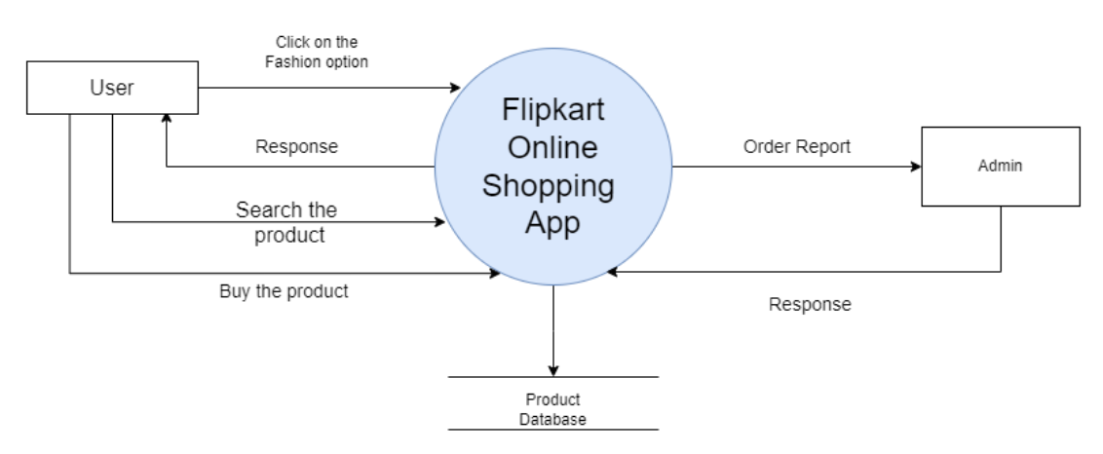

**[Fig: - Level-0 DFD Flipkart Shopping App]**

**Description of Level-0 Flipkart Shopping App: -**

**User to Flipkart:**

* User can search a product or view the product
* User can login in the website
* User can Buy the product or analyse the product
* User can also create their account

**Flipkart to User:**

* Flipkart response to the user and store the user data in the site.

**Flipkart to Admin**

* Website give the report of order to admin and admin response back to the site.

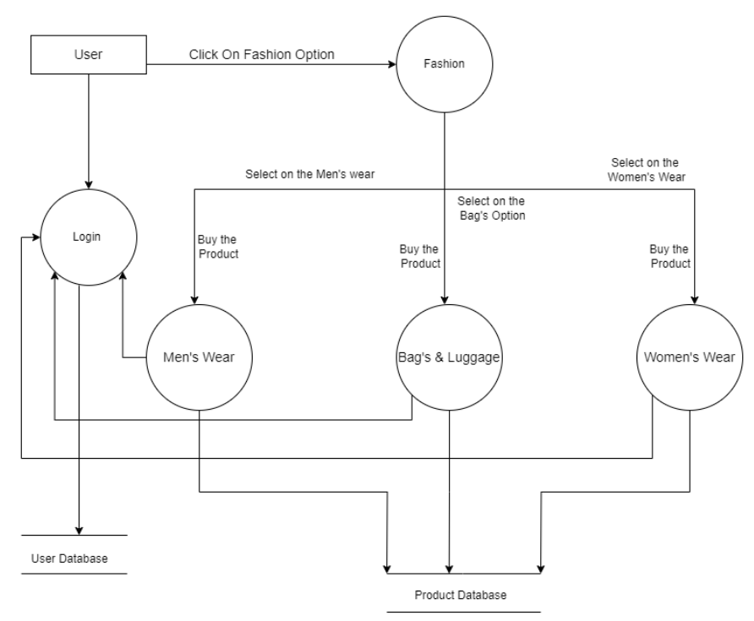**[Fig: - Level-1 DFD Flipkart Shopping App]**

**Description of Level-1 Flipkart Shopping App: -**

* User can search different product like in fashion in that they search on men's wear, Bags and luggage or women's wear as saw in the diagram.
* And all their products are store in product database.
* After buying the product all are go in payment process for further details.

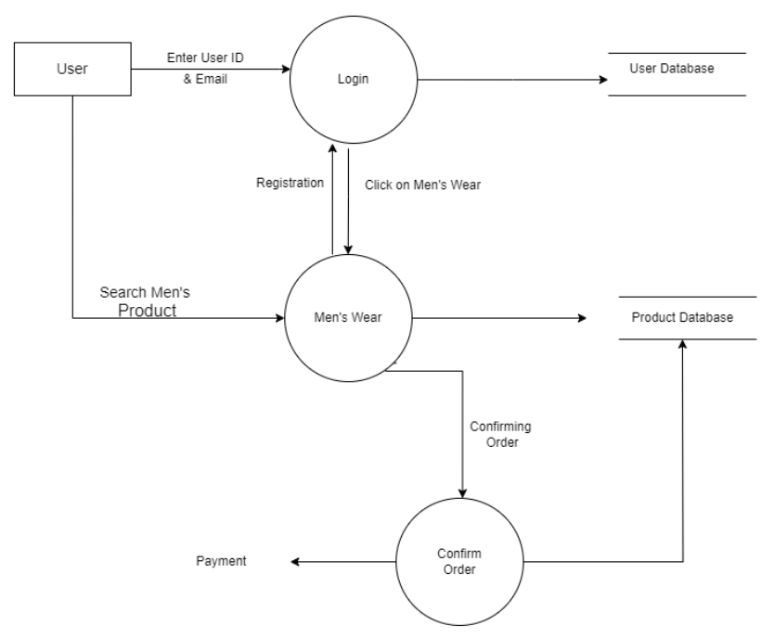

**[Fig: - Level-2.1 DFD Flipkart Shopping App]**

**Description of Level-2.1 Flipkart Shopping App: -**

* In this level all process we discussed in details
* user can enter their name, username, password, mobile to login process and all are store in user management database
* User can search a men's product in men's wear process and all are store in men's product database
* After viewing the product, you can buy the product or add to cart the product.

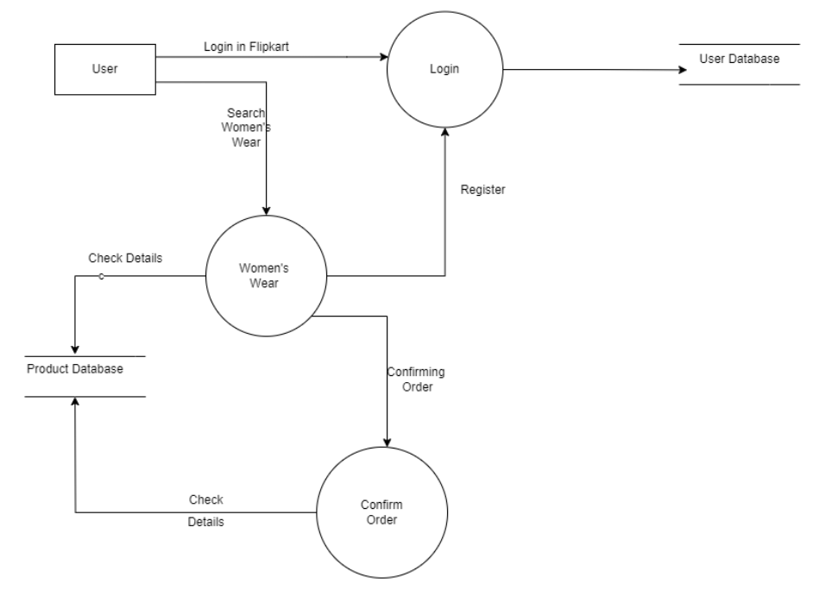

**[Fig: - Level-2.2 DFD Flipkart Shopping App]**

**Description of Level-2.2 Flipkart Shopping App: -**

* In this level all process we discussed in details
* user can enter their name, username, password, mobile to login process and all are store in user management database
* User can search a women's product in men's wear process and all are store in women's product database
* After viewing the product, you can buy the product or add to cart the product.

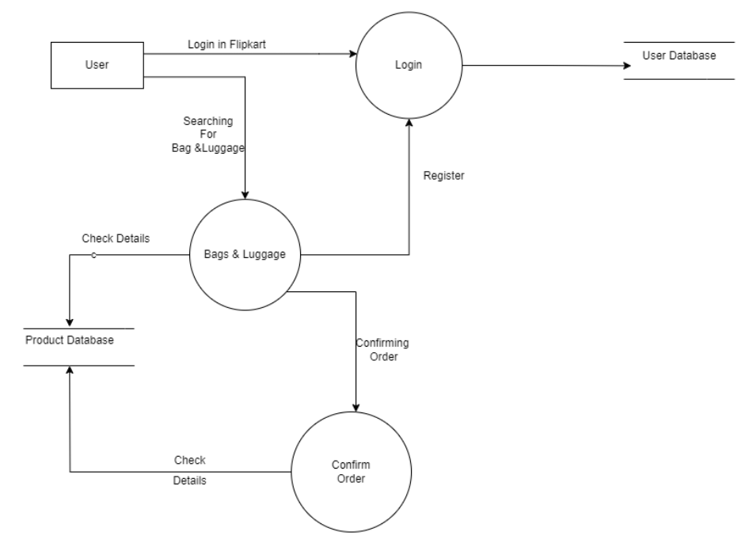

**[Fig: - Level-2.3 DFD Flipkart Shopping App]**

**Description of Level-2.3 Flipkart Shopping App: -**

* In this level all process we discussed in details
* user can enter their name, username, password, mobile to login process and all are store in user management database
* User can search a Bags & Luggage product in men's wear process and all are store in Bags & Luggage product database.
* After viewing the product, you can buy the product or add to cart the product.

1. **What is Flow chart? Create a flowchart to make addition of two numbers.**

* A flow chart is a graphical or symbolic representation of a process. Each step in the process is represented by a different symbol and contains a short description of the process step.

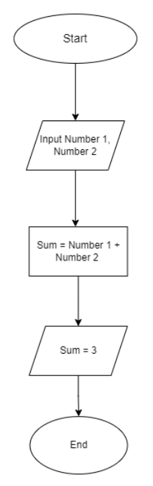

**[Fig: - Flowchart]**

1. **What is Use Case diagram? Create a use-case on bill payment on Paytm.**

* A use case diagram is a graphical depiction of a user’s possible interactions with a system.
* Use case diagram shows various use cases and different types of users the system has and will often be accompanied by other types of diagrams as well. The use cases are represented by either circles or ellipses.

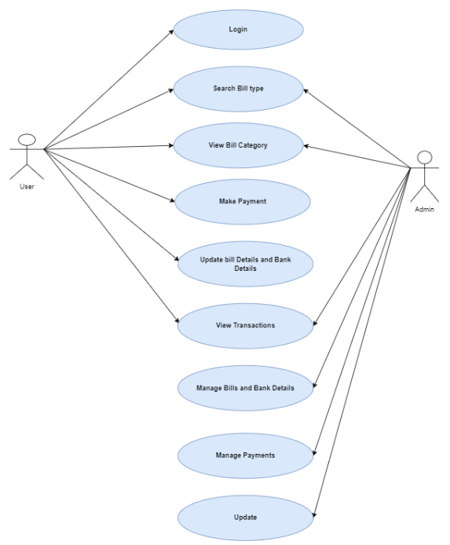

**[Fig: - Use case Diagram]**